Use Case Diagram and Specification

Front End Use Case Diagram

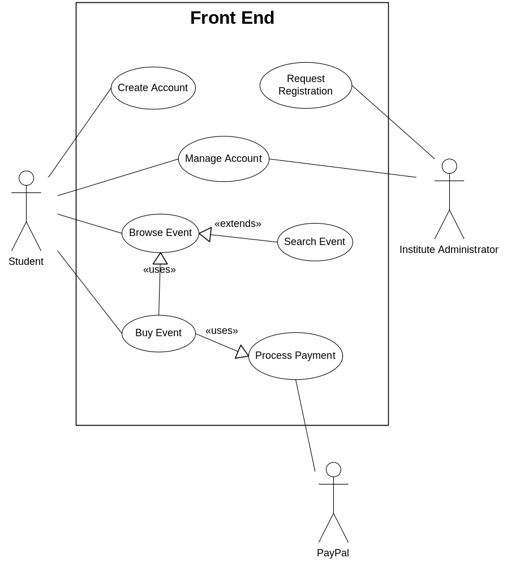

Front End Use Case Specification

Use Case Name | Create Account
Brief Description | This use case describes how student register and create account in our website
Actors | Student
Preconditions | Student is not logged in  Student is not already registered in our website
Basic Flow of Events | - Student open registration page  - Student fill registration form  - Student submit registration form  - Student receive verification email  - Student click an activation link in their verification email  - Registration complete, student is registered, their data is stored in database, and their status is activated
Alternative Flows | Invalid data  If in step 2 student do not provide a valid data, then  - Invalid field is marked  - Students are asked to change this incorrect data  Student do not activate their account  If in step 5 student do not click an activation link in their verification email, then  - Use case ends with failure condition
Post-Conditions | Successful completion  Student is registered to our website, their account is added to database, and their status is activated  Failure condition  Student account is not added to database, or their status is not activated

Use Case Name | Request Registration
Brief Description | This use case describes how institute administrator request for registration in our website
Actors | Institute Administrator
Preconditions | Institute administrator is not logged in  Institute administrator is not registered in our website
Basic Flow of Events | - Institute administrator open registration request page  - Institute administrator fill registration request form  - Institute administrator submit registration request form  - Institute administrator receive verification email  - Super administrator receive verification email (on the back end)  - Super administrator decide to approve request from institute administrator (on the back end)  - Institute administrator receive another verification email with activation link  - Institute administrator click an activation link in their email  - Registration complete, institute administrator is registered, their data is stored in database, and their status is activated
Alternative Flows | Invalid data  If in step 2 institute administrator do not provide a valid data, then  - Invalid field is marked  - Institute administrators are asked to change this incorrect data  Super administrator decide to reject request from institute administrator  If in step 6 super administrator decide to reject request from institute administrator  - Use case ends with failure condition  Institute administrator do not activate their account  If in step 5 student do not click an activation link in their verification email, then  - Use case ends with failure condition
Post-Conditions | Successful completion  Institute administrator is registered to our website, their account is added to database, and their status is activated  Failure condition  Institute administrator account is not added to database, or their status is not activated

Use Case Name | Manage Account
Brief Description | This use case describes how student and institute administrator manage their account, for example manage their personal data, change password, etc
Actors | Student, Institute Administrator
Preconditions | Student and institute administrator is logged in to our website
Basic Flow of Events | - Student or institute administrator open my account page  - Student or institute administrator edit their personal data the form in my account page  - Student or institute administrator submit form in my account page  - Student or institute administrator personal data is updated
Alternative Flows | Invalid data  If in step 2 student or institute administrator do not provide a valid data, then  - Invalid field is marked  - Student or institute administrators are asked to change this incorrect data
Post-Conditions | Successful completion  Student or institute administrator data is updated  Failure condition  Student or institute administrator is not updated

Use Case Name | Browse Event
Brief Description | This use case describes how student browse for events in our website when they want to buy an event, or just look around for an event
Actors | Student
Preconditions | -
Basic Flow of Events | - Student open home page  - Student click specific event  - Student is redirected detail page of event clicked before  - Student can add this event to their shopping cart or give a flag to indicate they like this event
Alternative Flows | -
Post-Conditions | Successful completion  Student able to browse for event  Failure condition  -

Use Case Name | Search Event
Brief Description | This use case describes how student search for a specific event in our website
Actors | Student
Preconditions | -
Basic Flow of Events | - Student open home page  - Student fill search form and choose specific category of event they want to find  - Student submit search form  - Student is redirected to search result page
Alternative Flows | No data found  If in step 4 no suitable event data found based on information provided by student, then  - Use case ends with failure condition
Post-Conditions | Successful completion  Specific event based on information provided by student is displayed  Failure condition  No specific event found based on information provided by student

Use Case Name | Buy Event
Brief Description | This use case describes how student buy an event in our website
Actors | Student
Preconditions | Student is logged in to our website
Basic Flow of Events | - Student browse our website for event  - Student added event to their shopping cart  - Student edit and review their shopping cart  - Student proceed to check out  - Student fill checkout form  - Student is redirected to payment page
Alternative Flows | Cancel to buy event  If in step 4 student cancel to buy event and do not proceed to checkout page, then  - Use case ends with failure condition  Invalid data  If in step 5 student do not provide a valid data, then  - Invalid field is marked  - Students are asked to change this incorrect data
Post-Conditions | Successful completion  Student able to add event to their shopping cart, proceed to checkout, and complete this process  Order history is added to database  Failure condition  Order history is not added to database

Use Case Name | Process Payment
Brief Description | This use case describes how payment being processed after student buy an event
Actors | Student, PayPal
Preconditions | Student have something on their shopping cart  Student proceed to checkout  Student provide correct information on checkout
Basic Flow of Events | - Shopping cart data from student is forwarded to PayPal  - Student is redirected to PayPal page  - Student provide their PayPal account information on PayPal page  - Student pay their event on PayPal page  - Student is redirected back to our website  - Relevant order history data is updated
Alternative Flows | Invalid data  If in step 3 student do not provide a valid data, then  - Invalid field is marked  - Students are asked to change this incorrect data  Not enough balance  If in step 4 student do not have enough balance, then  - Student is redirected back to our website  - Use case ends with failure condition
Post-Conditions | Successful completion  Payment is completed, relevant order history data in database is marked as paid  Failure condition  Payment is not completed, relevant order history data in database is not updated

Back End Use Case Diagram

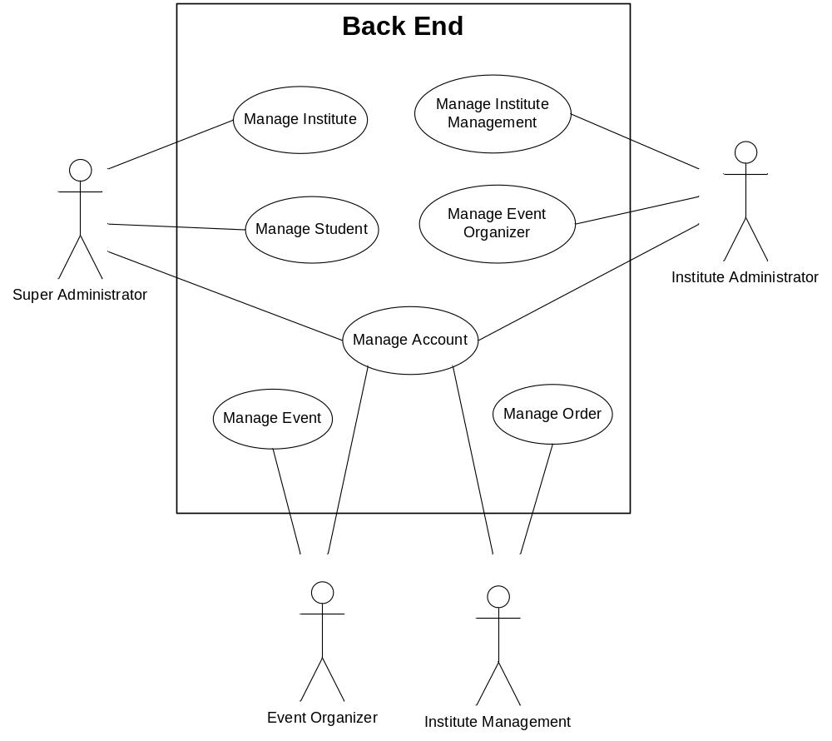

Back End Use Case Specification

Use Case Name | Manage Institute
Brief Description | This use case describes how super administrator manage an institute in our website, for example approve or reject its registration request, etc
Actors | Super Administrator
Preconditions | Super administrator is logged in to our website
Basic Flow of Events | - Super administrator open manage institute page  - Super administrator choose to add, edit, or delete institute administrator data  - Super administrator fill form in add or edit institute administrator data page  - Super administrator submit form in add or edit institute administrator data page
Alternative Flows | Delete institute administrator  If in step 2 super administrator choose to delete institute administrator data, then  - Relevant institute administrator data is deleted  Invalid data  If in step 3 super administrator do not provide a valid data, then  - Invalid field is marked  - Super administrator are asked to change this incorrect data
Post-Conditions | Successful completion  Relevant institute administrator data or status is updated  Failure condition  Relevant institute administrator data or status is not updated

Use Case Name | Manage Student
Brief Description | This use case describes how super administrator manage students in our website, for example activate or deactivate their status, edit their data, delete their data, etc
Actors | Super Administrator
Preconditions | Super administrator is logged in to our website
Basic Flow of Events | - Super administrator open manage student page  - Super administrator choose to add, edit, or delete student data  - Super administrator fill form in add or edit student data page  - Super administrator submit form in add or edit student data page
Alternative Flows | Delete student  If in step 2 super administrator choose to delete student data, then  - Relevant institute administrator data is deleted  Invalid data  If in step 3 super administrator do not provide a valid data, then  - Invalid field is marked  - Super administrator are asked to change this incorrect data
Post-Conditions | Successful completion  Relevant student data or status is updated  Failure condition  Relevant student data or status is not updated

Use Case Name | Manage Institute Management
Brief Description | This use case describes how institute administrators manage an institute management, for example add new institute management to their institute
Actors | Institute Administrator
Preconditions | Institute administrator is logged in to our website
Basic Flow of Events | - Institute administrator open manage institute management page  - Institute administrator choose to add, edit, or delete institute management data  - Institute administrator fill form in add or edit institute management data page  - Institute administrator submit form in add or edit institute management data page
Alternative Flows | Delete institute management  If in step 2 institute administrator choose to delete institute management data, then  - Relevant institute management data is deleted  Invalid data  If in step 3 institute administrator do not provide a valid data, then  - Invalid field is marked  - Institute administrator are asked to change this incorrect data
Post-Conditions | Successful completion  New institute management data is added to the database, or relevant existing institute management data or status is updated  Failure condition  No relevant institute management data is updated

Use Case Name | Manage Event Organizer
Brief Description | This use case describes how institute administrators manage an event organizer, for example add new event organizer to their institute
Actors | Institute Administrator
Preconditions | Institute administrator is logged in to our website
Basic Flow of Events | - Institute administrator open manage event organizer page  - Institute administrator choose to add, edit, or delete event organizer data  - Institute administrator fill form in add or edit event organizer data page  - Institute administrator submit form in add or edit event organizer data page
Alternative Flows | Delete event organizer  If in step 2 institute administrator choose to delete event organizer data, then  - Relevant event organizer data is deleted  Invalid data  If in step 3 institute administrator do not provide a valid data, then  - Invalid field is marked  - Institute administrator are asked to change this incorrect data
Post-Conditions | Successful completion  New event organizer data is added to the database, or relevant existing event organizer data or status is updated  Failure condition  No relevant event organizer data is updated

Use Case Name | Manage Account
Brief Description | This use case describes how super administrator, institute administrator, event organizer, and institute management manage their account, for example edit personal data, change password, etc
Actors | Super Administrator, Institute Administrator, Event Organizer, Institute Management
Preconditions | Super administrator, institute administrator, event organizer, or institute management is logged in to our website
Basic Flow of Events | - Super administrator, institute administrator, event organizer, or institute management open my account page  - Super administrator, institute administrator, event organizer, or institute management edit their personal data on the form in my account page  - Super administrator, institute administrator, event organizer, or institute management submit form in my account page  - Super administrator, institute administrator, event organizer, or institute management personal data is updated
Alternative Flows | Invalid data  If in step 2 super administrator, institute administrator, event organizer, or institute management do not provide a valid data, then  - Invalid field is marked  - Student or institute administrators are asked to change this incorrect data
Post-Conditions | Successful completion  Super administrator, institute administrator, event organizer, or institute management data is updated  Failure condition  Super administrator, institute administrator, event organizer, or institute management data is not updated

Use Case Name | Manage Event
Brief Description | This use case describes how event organizer manage events of an institute, add new event, edit existing event, delete existing event, etc
Actors | Event Organizer
Preconditions | Event organizer is logged in to our website
Basic Flow of Events | - Event organizer open manage event page  - Event organizer choose to add, edit, or delete event data  - Event organizer fill form in add or edit event data page  - Event organizer submit form in add or edit event data page
Alternative Flows | Delete event  If in step 2 event organizer choose to delete event data, then  - Relevant event data is deleted  Invalid data  If in step 3 event organizer do not provide a valid data, then  - Invalid field is marked  - Event organizer are asked to change this incorrect data
Post-Conditions | Successful completion  New event data is added to the database, or relevant existing event data is updated  Failure condition  No relevant event data is updated

Use Case Name | Manage Order
Brief Description | This use case describes how institute management manage order history of an institute
Actors | Institute Management
Preconditions | Institute management is logged in to our website
Basic Flow of Events | - Institute management open manage order page  - Institute management choose to edit, or delete order history data  - Institute management fill form in edit order history data page  - Institute management submit form in edit order history data page
Alternative Flows | Delete order history  If in step 2 institute management choose to delete order history data, then  - Relevant order history data is deleted  Invalid data  If in step 3 institute management do not provide a valid data, then  - Invalid field is marked  - Institute management are asked to change this incorrect data
Post-Conditions | Successful completion  Relevant order history data or status is updated  Failure condition  Relevant order history data or status is not updated

